**University of Minnesota**

# **Final Project Report**

**Ali Al Mashrafi**

**Yahai Al Hinaai**

**Fahad Al Sawafi**

**Instructor: Kia Bazargan**

**Project 1**

**A Room Temperature Controller**

**Introduction:**

Our project is a room temperature controller that allows the user interface with the microcontroller by push buttons or using his smart phone via a bluetooth connectivity. LM35 will be used to measure the actual temperature of the room using ADC function. The LCD will be used to display the actual temperature and the setup temperature using the I2C function. There should be 5 push button switches, which are ON, OFF, Increase Temperature, Decrease Temperature, and Select mode (FAN, Heater, or Air Conditioner). There should be 2 LED indicators to indicate if the fan or the air conditioner is on. For the heater mode, we are using a space heater since it is available. The 2 LEDs and the heater are powered via the power circuit built to transform 120VAC to the appropriate DC voltage for each.

**Components Used:**

* Pic24
* Heat Sensor LM35
* Bluetooth Module HC-06
* LCD Display
* Transformer
* Triac Switches
* opto isolators
* Heat Sinks
* Switch regulators
* LEDs
* A Space Heater

**Schematic:**

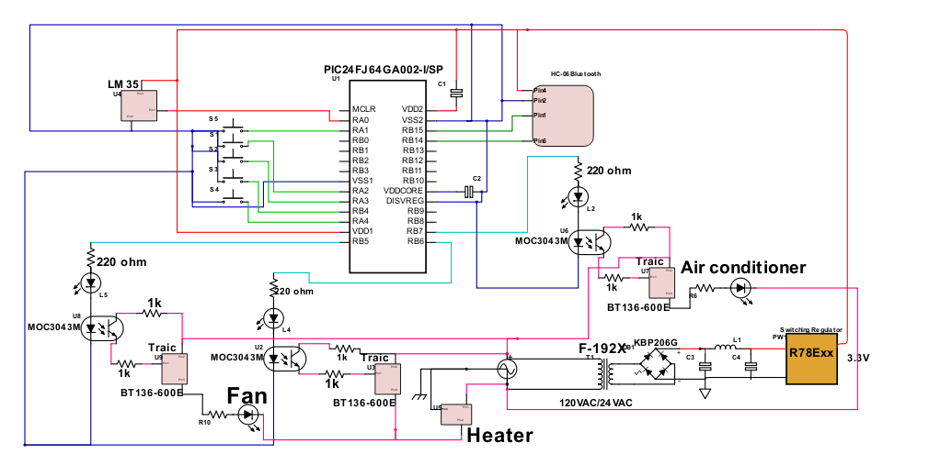

Figure 1: Shown is the circuit schematic used in the room temperature controller

**Pictures:**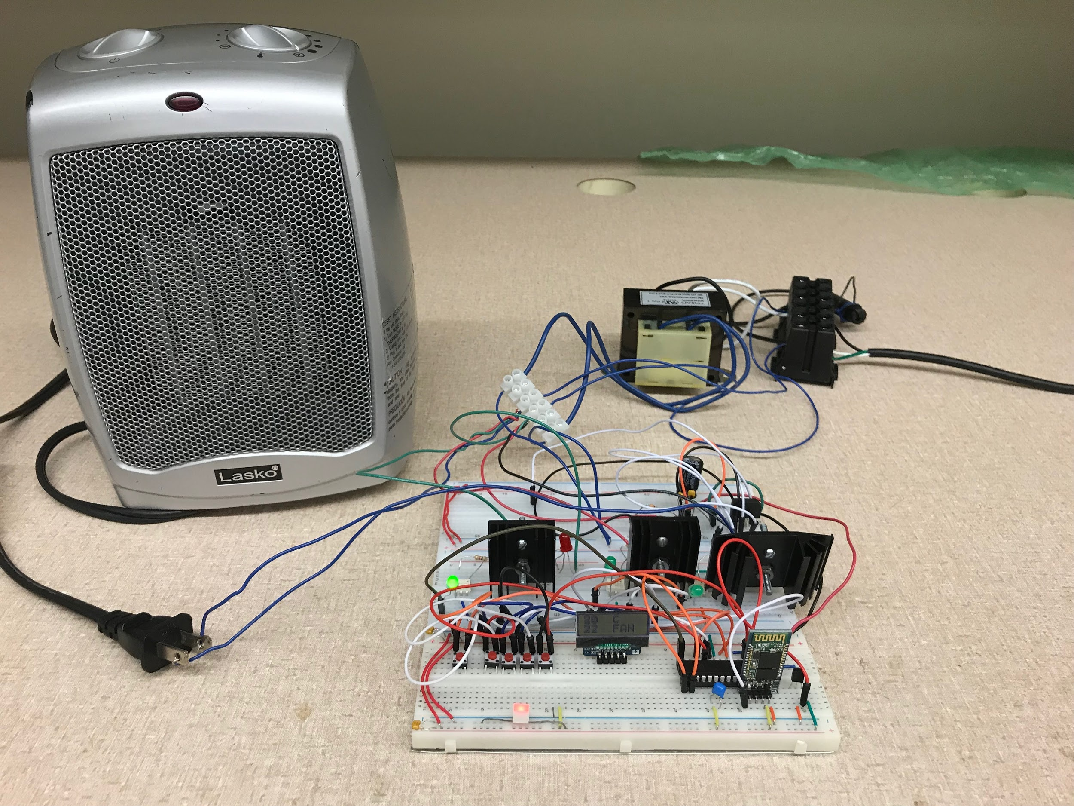

Figure 2: Shown is the room temperature controller with all components connected together 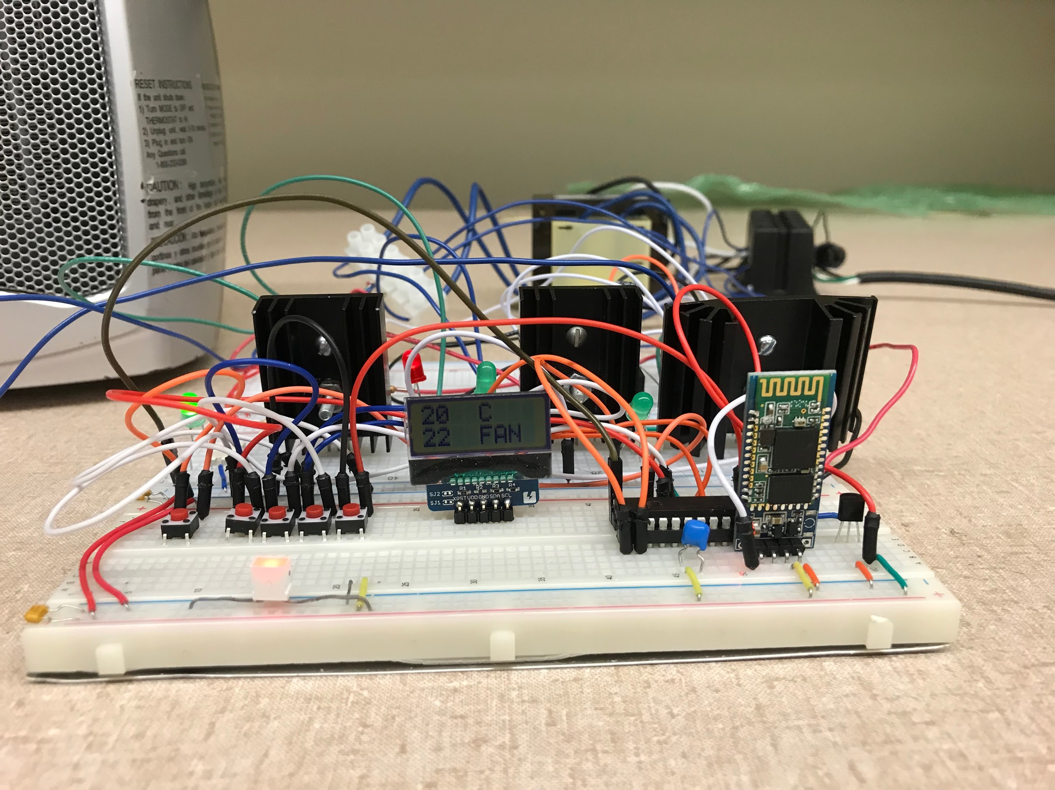

Figure 3: The manual user interference with all features displayed on the LCD screen display

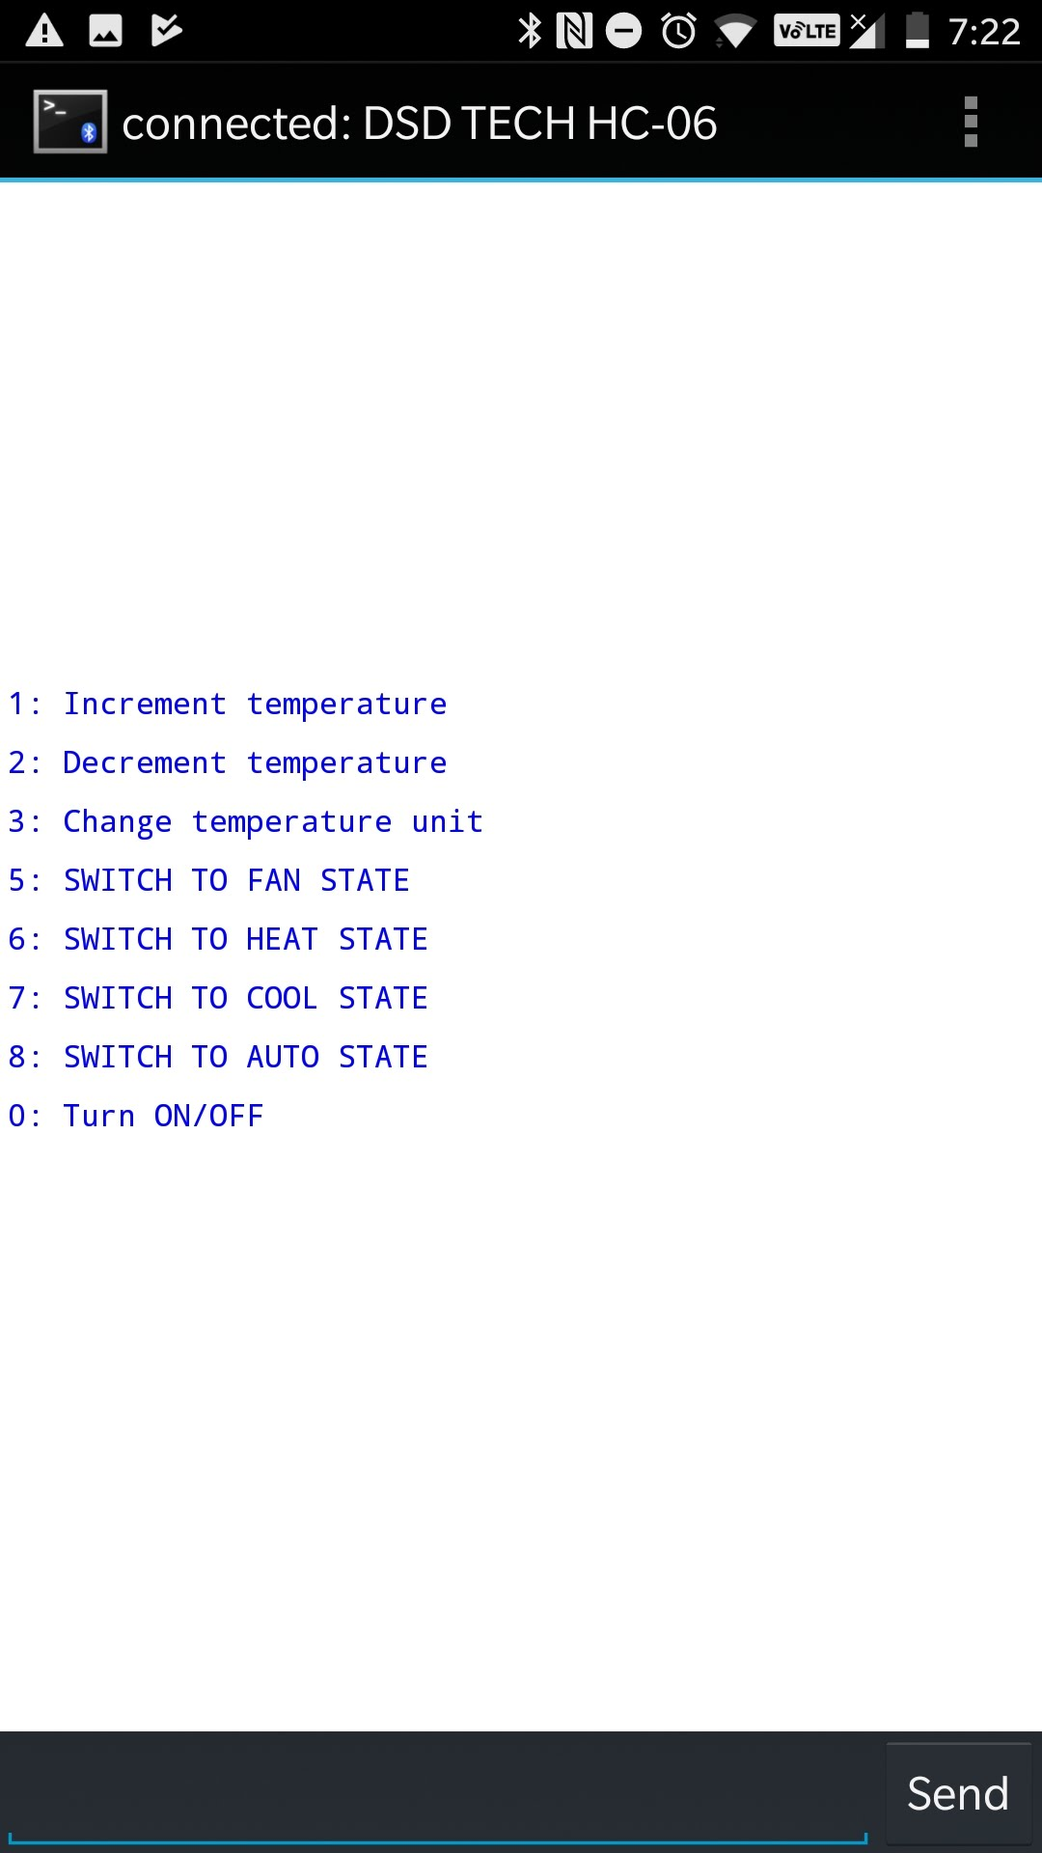

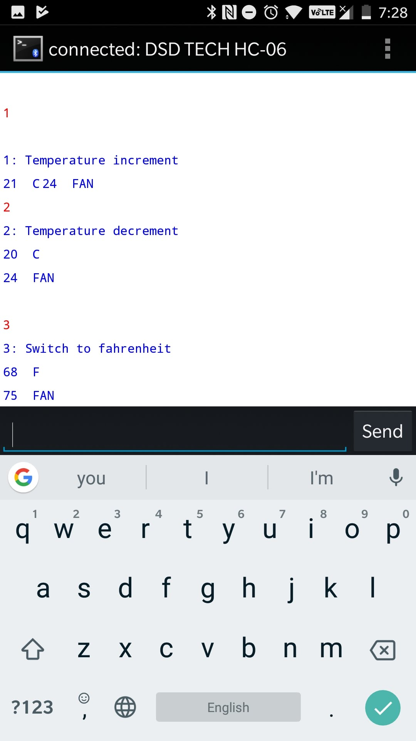

Figure 4: The Bluetooth user interference with the user commands page shown on a smartphone.

**The Code**

**Room Temperature Control:**

1. **Library description:**
2. **Function description:**
3. **Basic Usage Examples:**

The user is able to input a desired temperature, so that the heater or the cooler will turn on relatively to meet that temperature. When the actual temperature of the room meets the desired temperature, the microcontroller tell the system to turn off the active device ( heater, cooler, fan).

1. **Advanced Usage Examples:**

Set the selected mode to AUTO mode, the the user should notice that the device will be working automatically corresponding to the difference between the actual room temperature and the desired temperature. For instance, the system will turn on the cooler if the actual temperature was 100 F, and the desired temperature is set to be 75 F.

1. **Appendix A:**

Submission..

**Project 2**

**A PID Power Controller**

**Introduction:**

This project was implemented.

**Components Used:**

* Pic24
* Heat Sensor LM35
* LCD Display
* Transformer
* Triac Switches
* opto isolators
* Heat Sinks
* Switch regulators
* LEDs

**Schematic:**

**Pictures:**

**The Code**

**Room Temperature Control:**

1. **Library description:**
2. **Function description:**
3. **Basic Usage Examples:**
4. **Advanced Usage Examples:**
5. **Appendix A:**

Submission..